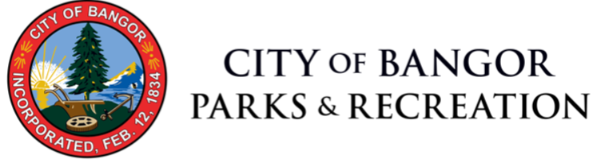 | Swim Lesson Descriptions

Level 1: Water Comfort and Basic Skills
Level 1 is recommended for young children (3 to 6 years of age) with little to no experience in the water, or younger children who are uncomfortable with the water. Level 1 focuses on developing basic skills such as submerging the face, floating, arm and leg movements, and blowing bubbles. Children who graduate from level 1 will be comfortable with the water and grasp concepts critical to developing strong swimmers.

Level 2: Fundamental Skills
Level 2 is recommended for young children (4 to 8 years of age) who are comfortable with the water and have a foundation of basic skills, but lack more advanced skills critical to developing strong swimmers, including: arm strokes, rotary breathing, flutter and breaststroke kick, body position, and coordination of movements.

Level 3: Stroke Development
Level 3 is for children who are already swimmers but lack coordination of strokes. Level 3 will focus on honing elementary skills from Level 2 and developing a swimmer capable of performing the four fundamental strokes: freestyle, backstroke, breaststroke, and butterfly.

Level 4 Stroke Refinement / Level 5 Advanced Skills & Endurance
Level 4 is for an already strong and competent swimmer. The focus of level 4 will be refining stroke techniques for the four fundamental strokes and beginning to build endurance, through increased activity in the water and an optimization of technique. Level 4 is not for swimmers who have not yet mastered the basics of the fundamental strokes, rather swimmers looking to improve their technique and endurance.
Level 5 is geared towards swimmers looking to master their technique and improve endurance. Level 5 will strongly emphasize technique, and introduce more advanced water skills – diving, flip-turns, underwater dolphin kick, etc. – as would be typically found in a pre- or youth swim team. Students who successfully graduate Level 5 will be of a skill level where joining a swim team would be an appropriate next step.

Swim Lesson Program Objectives:

Levels one through three are to be thought of as primarily introductory courses. Between the levels there are profound differences, but all three are meant to develop basic, yet critical skills. The primary challenge with very young swimmers is making them comfortable with the water. Physically they are not capable of learning meaningful stroke technique, rather only basic motions that are associated with swimming, such as the underwater catch or “scoop” associated with freestyle, butterfly, and breaststroke; or floating on their back, as would be necessary for backstroke. The most important skills for level one students to master before graduating are: placing their face in the water and blowing bubbles, and floating on both their stomach and back.
For older students, who are completely comfortable with all skills in level one, level two will continue to focus on comfort in the water while also incorporating basic skills. At this age it becomes possible to implement small bits of technique and stroke fundamentals. The concept of streamline position should also be incorporated with level two, as it encourages proper bodyline for all fundamentals strokes and forces students to be more comfortable with keeping their head in a neutral position. Beyond bodyline and floating, students should begin to develop both flutter and breaststroke kicks, as well as arm strokes for freestyle, backstroke, and breaststroke. A strong emphasis will be placed on the fundamentals of the strokes rather than incorporating them into cohesive strokes, though that can be encouraged.
Level three will be the first to implement strokes as a whole. Beginning with the foundation developed in level one and two, freestyle and backstroke are the first logical steps. By taking a layered approach and slowly building students into the strokes there can be both an emphasis on technique and stroke coordination. Breaststroke and butterfly are both far more difficult in terms of timing, and full mastery of the strokes should not be expected by the end of level three, but an introduction is necessary, as well as a development of a rudimentary stroke.
As students graduating level three should have an already strong freestyle and backstroke, the focus of level four will be refining these. The most important refinement that needs to be made for both strokes is body position – often swimmers in level four are working against themselves by picking their heads up and dropping their hips in the water. Students who cannot complete an extended distance of freestyle or backstroke without picking their head up to breath cannot graduate level four. Butterfly and breaststroke both need to be refined in level four, which becomes easier with increased endurance and improved skills. An introduction to more advanced skills such as dives and flip-turns should be incorporated slightly, yet is not a strong focus of level four.
Level five caters to swimmers who can satisfactorily complete all four fundamental strokes but need more technique development. Level five is, in a sense, a pre-swim team program. A strong focus will be placed on technique, but more endurance-based work will be incorporated. Flip-turns and dives will further refined in level five, and by graduation, students should be able to enter the water in streamline position and complete two lengths (fifty yards) of any fundamental stroke.

